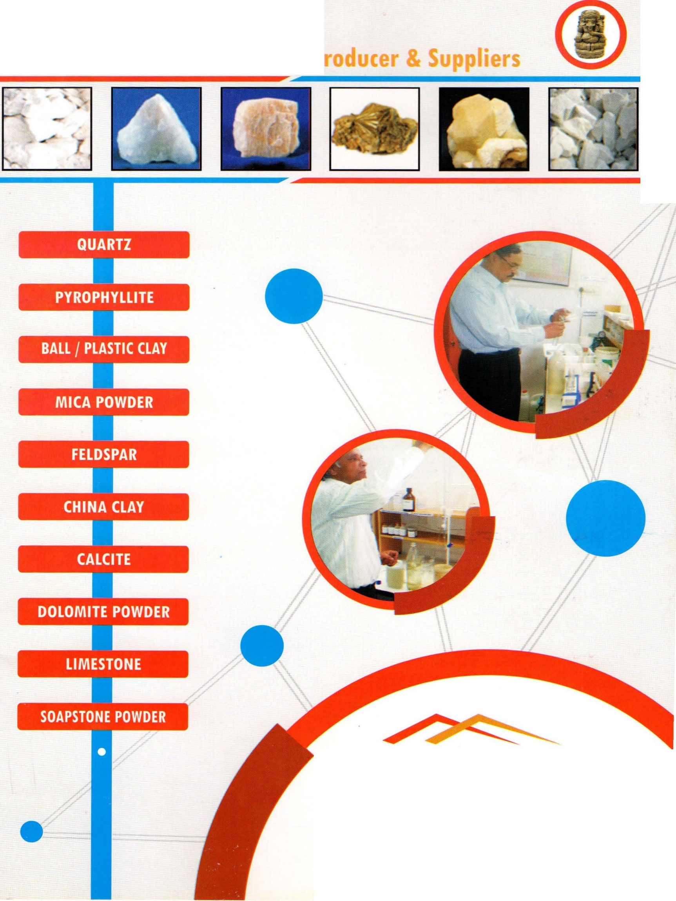

**R.K. Minerals**

**R. K. Minerals**

## 12, Vinayak Nagar, Bohra Ganesh Ji Udaipu r-313001 (Raj .)

Phone : +919829161803, (0) 0294-2490803

Email : [rkminerals_](mailto:rkminerals_udr@yahoo.com)[udr@yahoo.com](mailto:udr@yahoo.com)

/



M/s. R.K. Minerals has been engaged in mining of minerals. They are processing and supplying them to various industrial u nits. lt is headed by Shri Amit Saxena a Mining Engineer and a qualified person duly recognized by the Indian Bu rea u of Mines, Govt. oflndia. The organization also has a mineral testing laboratory which makes it self- dependent upto a great extent. Mr. Amit Saxena has been supplying Soapstone (Talc), Calcite, Quartz, China Clay and Dolomite for more than last 15 years and has attained good reputation in the market. lt has a sister concern named as M/s. Apex Enviro Lab. which is duly accredited by NABL (National Accreditation Board for Testing & Laboratory).

ln the course of processing, the samples of powder are taken and analysed at the laboratory. Further, prior to dispatching the mineral again samples are taken, analytical report prepared and sent to the consumer anlongwith the consignment. This ensure quality control. The organization is managed by highly experienced professionals like Mining Engineers, Geo Surveyors and other technical staff.

**Pyrophyllite**

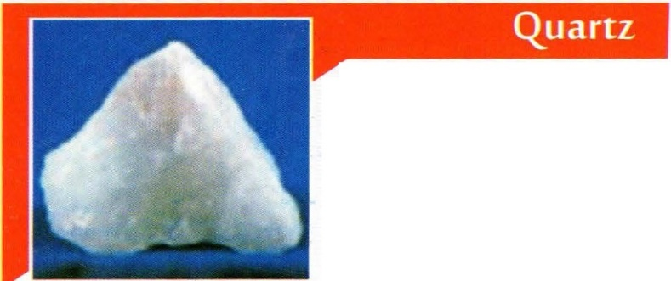Quartz is the second most abundant mineral in the earth's crust, after feldspar. Chemically, quartz is silica, or silicon dioxide, Si0 • Quartz is a constituent of granite and other felsic igneous rocks. lt

2

i s v e r y c o m m o n i n sedimentary rock such as Sandstone & shale and is also present in variable amou nt as an accessory mineral.

Uses of Quartz: lt is suitable for white opaque transparent glaze and white ware body transparent glaze. Inferior quality is suitable for ceramic body. Quartz is rather hard having a hardness of 7 on the Moh's hard ness scale, and has a glassy (vitreous) luster. Quartz is physically and chemically resistant to weathering . Most of the quartz is contained in granite, a smaller amou nd in metamorphic rocks, and a small amount in sedimentary rocks. However the highest concentration of quartz can be found in sedimentary and metamorphic rock as sand stone and quartzite as well as in alluvium and marine snd.

Uses:1t finds use in glass industry and ceramic industry.

The white sands typically found in river beds and on beaches are usually composed mainly of quartz.

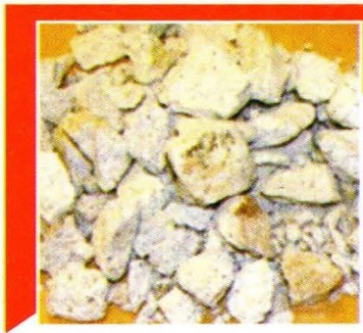**Ball *I***

**Plastic clay**

Ballclays are kaolinitic sedime ntary clays that commonly consist of 20-80% kaolinite, 10-25% mica, 6-65% quartz. Our prod uct is m high demand in the market. 1t is available at the most nominal

price.

Uses:The main utility of ball clay is in plastic industry due to its high bonding qualities and tensile strength. lt is added in preparation of body composition of vitreous sanitary wares, bath tubs, and hotel chinaware, and floor, wall tiles. lt is also utilized in production of porcelain , spark plugs etc.

•

Pyrophyllite 1s i som o r p h o u s w i t h t h e common mineral Talc, but has alumin um in place of the magnesium .lt is very similar to Ta lc, wi th very si m i l a r properties and habits.

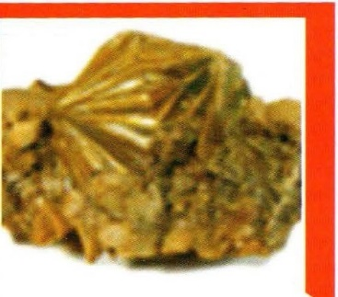lt is of metamorphic origin formed as a result of metamorphism of deposits containing. Kaoline, diosbore, quartz assemblage.

We are engaged in supplying a diverse range of Pyrophyllite Powder that is a secondary mineral of composition Al 0r Si0 .H 0. lt is hydrated alu minu m silicate.

2 4 2 2

Specialty: Pyrophyllite is harder in comparison to talc. lt does not flux when fired.

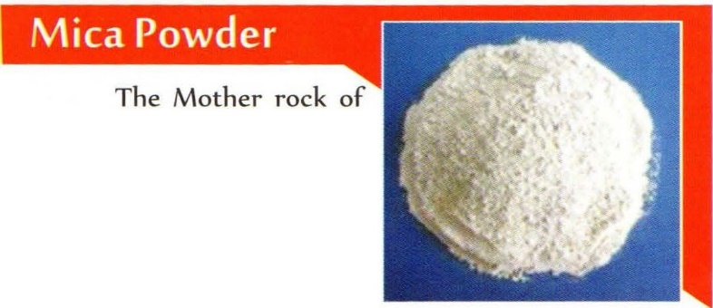Uses: lt is used in the ceramic products, particularly refractory. Pyrophyllite is used for cera mics, in paints, insecticides, and in the production of rubber. lt is also used as a minor ornamental stone for carvings and sculptures.

Mica is Pegmatite which is of igneous origin. Good quality of mica deposits occur when pegmatite intrudes into the country rock mica schist. We prod uce a superior grade of

Mica Powder. Generally mica is found in book form and can be creaved into thin sheets. Mica is chemically silicate of alu minum having water of crystallization and containing elements like potassium, sodium, magnesium , lithium , vaedium & iron.

Uses: Due to its dielectric property & lower power factor it is invaluable to electrical industry. lt can with stand high temperature also.Mica powder is used as a filler in rubber, as flex standard in paints. lt is also used for electro coating, water proof packing as a roofing material.

. '

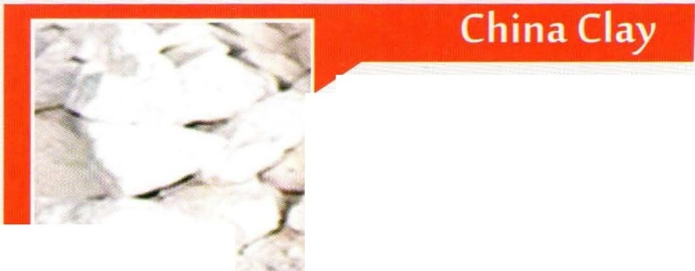China Clay is actually kaolinite. Its chemical composition is Al 2Si,05 (0H)4. It is a layered silicate mineral. Rocks that are rich in kaolinite are known as kaolin or china clay.

The China Clay supplied by us meets the international standard and is high in demand. It is produced by levigation of raw china clay obtained from mine. It is available at a very competitive price. It is marketed as super textile, paper, pottery and rubber grades. The grading of the material is primarily done on the basis of whiteness and grit content.

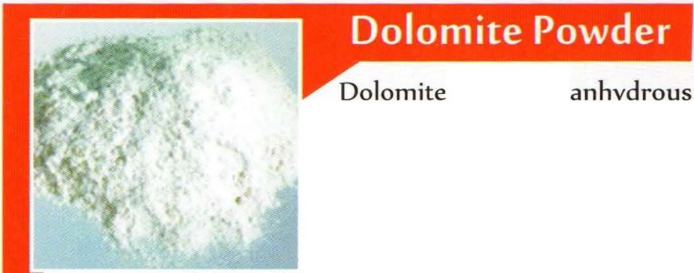Uses: It is used for manufacturing electrical, insulator. It is also used in pharmaceutical and cosmetic industry. It is used in large quantity as filler & reinforcing agent in rubber goods.

1s an

carbonate mineral composed of c a lci u m m a gn esi u m c a r b o n a t e , i d e a l l y C a M g ( C 03 ), . I t i s o f sedimentary origin supposed

to have been formed due to alteration of calcium carbonate sediments or rocks by sea-water rich in magnesia. A wide variety of dolomite powder is available with us.

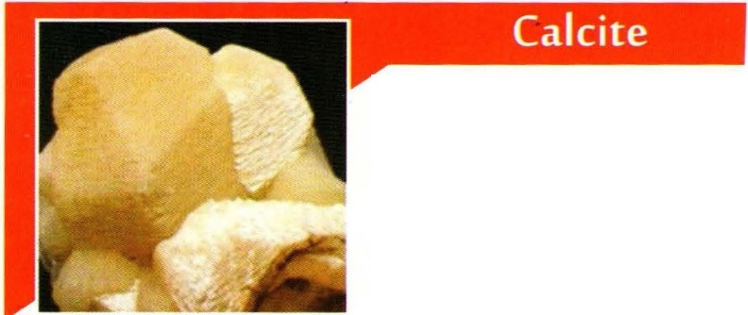Uses: Iron & steel ind ustries are its largest consumers. It is also used in glass industry. A wide variety of dolomite powder is available with us.

Calcite is a carbonate mineral a n d t h e m o st st a b l e p ol y m o r p h of ca l ci u m carbonate (CaC0 )

3

Uses: Calcite is primary ore of calcium. It is also used in ma n ufactu rer of fertilizer,

metals, glass rubber & paint. Calcite is pure carbonate. It occurs in a variety of shades and colours

Uses: It is essential to cement industry and a number of chemicals are also manufactured with this.

most the abundant rock-forming mineral in natu re and is basically aluminium silicate with potassium, sodium & calcium. It is generally ma rketed after grinding to specified a mesh according to consumer's needs

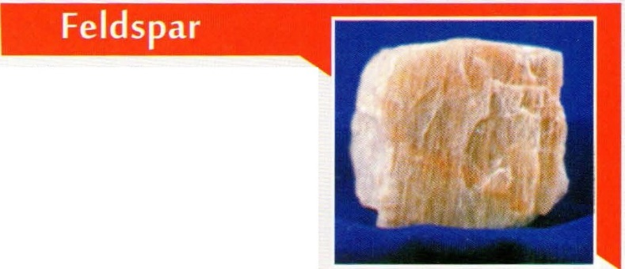

feldspar is formed as a result of crystallization from magma veins in both intrusive and extrusive igneous rock and are also present in many types of metamorphic &

sedimentary rocks. It is the

f eldspars (KAISi 0 - NaA1Si 0 - CaAl Si20 ) are a group of rock-forming tectosilicateminerals that make up as much as 60% of the Earth's crust

3 8 3 8 2 8

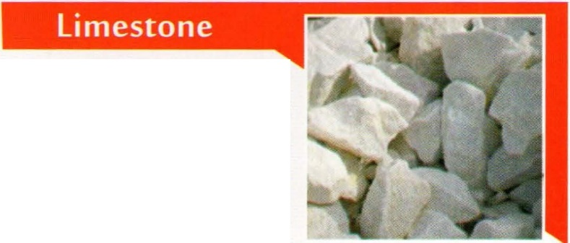Uses: It is used in man ufactu ring glass pottery in high grade colourless glass.It is also used in ceramic industry as glazed in chinawa re.

Limestone is a very common sedimenta ry rock consisting of more than 50% calcium carbonate. Although it occurs in many different forms, its origin can be traced back to

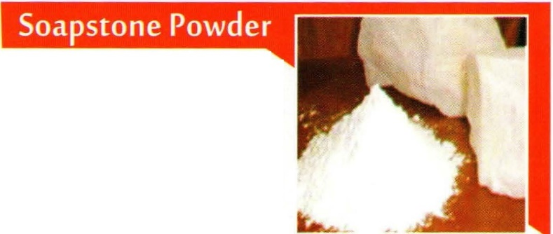either chemical or processes that occu rred in the geological past, often tens to hundreds of millions of years ago. Its largest consumer are sugar and cement industries. It is available with us at a very competitive price.

Soapstone (also known as steatite, or soaprock) is a talc-schist, which is a type of metamorphic rock. It is largely composed of the mineral talc and is thus rich in magnesium.

It is prod uced by dynamothermal metamorphism and metasomatism. The pure white quality of soapstone after grinding to powder is known as 'French chalk' in trade.

Uses: It is mainly used for carvmg out pots, bricks. It is employed as linings for various kinds of stoves, ovens and fireboxes.

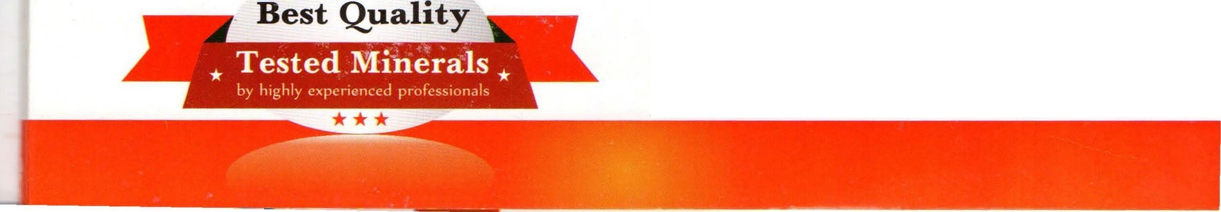

We produce and supply a wide range of soapstone at a very competitive price. Bricks made from crushed soapstone, bonded with silicates of soda are used for manufactu ring of furnaces in which crude lead is softened.

...,,,,,... --....

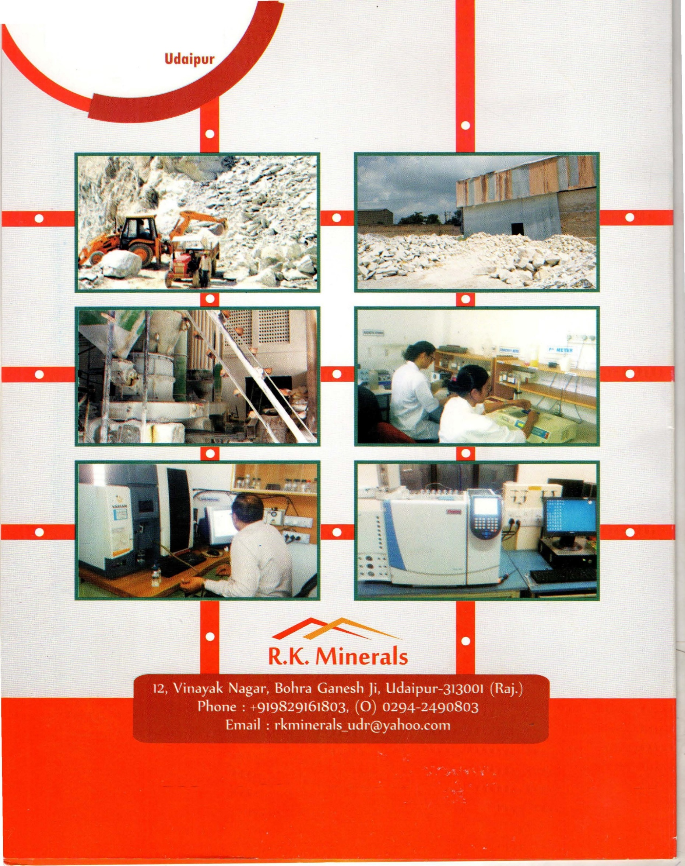

--....

R.K.M i nerals